**Alabama State Department of Education**

**School Principal Leadership and Mentoring Act**

**2024 UNITED Conference APLDS Clock Hour Documentation Form**

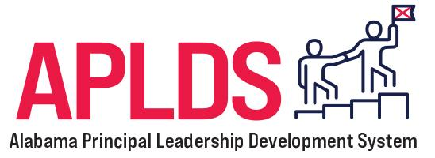

**DIRECTIONS:** To submit documentation and receive clock hour credit toward the Principal Act high-quality professional learning program requirement, complete the following:

1. **Participant Information**
2. **Conference Attendance Log**
   1. This document verifies your attendance at the conference sessions. Record complete information for each session you attended and obtain the speaker’s signature to verify your attendance.
   2. If, during a few of your sessions, you cannot access the speaker and are unable to obtain a signature, please provide a 2-3 sentence synopsis in your own words summarizing the conference session. Type directly on the log document.

**SUBMISSION DEADLINE: July 31, 2024**

Submissions are accepted via email to Dr. Anna Shepherd-Jones at [anna.jones@alsde.edu](mailto:anna.jones@alsde.edu).

|  |
| --- |
| **Participant Information** |
| **First and Last Name:** |
| **Email Address:** |
| **Phone Number:** |
| **How many clock hours are you requesting?** (Note: up to 22 clock hours can be awarded) |
| **Participant’s Signature:**  (By signing, you verify that the information on this documentation form is complete and accurate.) |

|  |  |  |  |
| --- | --- | --- | --- |
| **Conference Attendance Log** | | | |
| **Session Date** | **Session Length** (e.g., 45 minutes) | **Session Name** | **Speaker’s Signature *or* Session Synopsis** |
|  |  |  |  |
|  |  |  |  |
|  |  |  |  |
|  |  |  |  |
|  |  |  |  |
|  |  |  |  |
|  |  |  |  |
|  |  |  |  |
|  |  |  |  |
|  |  |  |  |
|  |  |  |  |
|  |  |  |  |
|  |  |  |  |
|  |  |  |  |
|  |  |  |  |
|  |  |  |  |
|  |  |  |  |

